SIMATS ENGINEERING
ASSESSMENT TOOL 1 – High (Coding Challenge)
COURSE CODE: CSA09 COURSE NAME: Programming in Java
COURSE OUTCOME COVERED
CO1: Apply object-oriented programming principles such as classes, objects, encapsulation, data hiding, inheritance, and polymorphism to design and implement entity manipulations (BL 3,BL 4)
QUESTIONS: 5 Total Marks: 100
ANNEXURE A Coding Challenge
Code of Conduct:
I L Nihas Goud(192472346) (Name / Reg No) certify that this submission is my original work and that I have adhered to the guidelines specified for this assessment. I understand that any violation of academic integrity rules will result in disciplinary action.
Signature of the student: NIHASGOUD
RUBRICS FOR CALCULATION:
Criteria | Weightage | Level 4 (Exemplary) | Level 3 (Proficient) | Level 2 (Developing) | Level 1 (Beginning)
Problem Understanding | 20% | Clearly understands problem constraints, edge cases, and competitive requirements | Understands problem with minor gaps in constraints | Partial understanding; misses key constraints | Misinterprets problem or constraints
Algorithm | 25% | Selects optimal algorithm with best time and space complexity for competitive constraints | Uses efficient algorithm with minor scope for improvement | Uses basic/inefficient approach | No clear algorithmic approach
Code Implementation | 20% | Writes correct, efficient, and clean code that passes all constraints | Code works with minor errors or inefficiencies | Partially correct code; fails for some cases | Code does not execute or gives incorrect results
Competitive Performance | 20% | Solves problem within time limits and handles large inputs effectively | Solves within acceptable time with minor delays | Struggles with time limits or larger inputs | Unable to solve within time constraints
Test Case Handling | 15% | Handles all test cases including edge and hidden cases | Handles most test cases | Misses important edge cases | Fails on multiple test cases
ANNEXURE Coding Challenge
1. Vehicle Rental System using Runtime Polymorphism
Develop a vehicle rental system with a superclass Vehicle and subclasses Car, Bike, and Bus. Override the method calculateRent(int days) in each subclass. Store vehicles in an array of Vehicle references and generate rental bills dynamically. Also, construct suitable test cases to validate rent calculation for different vehicle categories.
Code:
import java.util.Scanner;

// Base Class
class Vehicle {
protected int vehicleId;
protected String vehicleName;

Vehicle(int vehicleId, String vehicleName) {
this.vehicleId = vehicleId;
this.vehicleName = vehicleName;
}

public double calculateRent(int days) {
return 0;
}

public void displayBill(int days) {
System.out.println("\n------ Rental Bill ------");
System.out.println("Vehicle ID : " + vehicleId);
System.out.println("Vehicle Name : " + vehicleName);
System.out.println("Days Rented : " + days);
System.out.println("Total Rent : Rs. " + calculateRent(days));
System.out.println("-------------------------");
}
}

// Subclass - Car
class Car extends Vehicle {
private double ratePerDay;

Car(int vehicleId, String vehicleName, double ratePerDay) {
super(vehicleId, vehicleName);
this.ratePerDay = ratePerDay;
}

@Override
public double calculateRent(int days) {
return days * ratePerDay;
}
}

// Subclass - Bike
class Bike extends Vehicle {
private double ratePerDay;

Bike(int vehicleId, String vehicleName, double ratePerDay) {
super(vehicleId, vehicleName);
this.ratePerDay = ratePerDay;
}

@Override
public double calculateRent(int days) {
return days * ratePerDay;
}
}

// Subclass - Bus
class Bus extends Vehicle {
private double ratePerDay;
private double driverCharge;

Bus(int vehicleId, String vehicleName, double ratePerDay, double driverCharge) {
super(vehicleId, vehicleName);
this.ratePerDay = ratePerDay;
this.driverCharge = driverCharge;
}

@Override
public double calculateRent(int days) {
return (days * ratePerDay) + driverCharge;
}
}

// Main Class
public class Main {
public static void main(String[] args) {
Scanner sc = new Scanner(System.in);

// Array of Vehicle references (Runtime Polymorphism)
Vehicle vehicles[] = new Vehicle[3];
vehicles[0] = new Car(101, "Swift Dzire", 1500);
vehicles[1] = new Bike(102, "Royal Enfield", 500);
vehicles[2] = new Bus(103, "Volvo AC Bus", 5000, 2000);

int choice;
do {
System.out.println("\n===== VEHICLE RENTAL SYSTEM =====");
System.out.println("1. Car - Swift Dzire (Rs.1500/day)");
System.out.println("2. Bike - Royal Enfield (Rs.500/day)");
System.out.println("3. Bus - Volvo AC Bus (Rs.5000/day + Rs.2000 driver)");
System.out.println("4. Exit");
System.out.print("Enter Choice: ");
choice = sc.nextInt();

if (choice >= 1 && choice <= 3) {
System.out.print("Enter Number of Days: ");
int days = sc.nextInt();
vehicles[choice - 1].displayBill(days);
} else if (choice != 4) {
System.out.println("Invalid Choice.");
}
} while (choice != 4);

System.out.println("Thank You!");
sc.close();
}
}
Output:
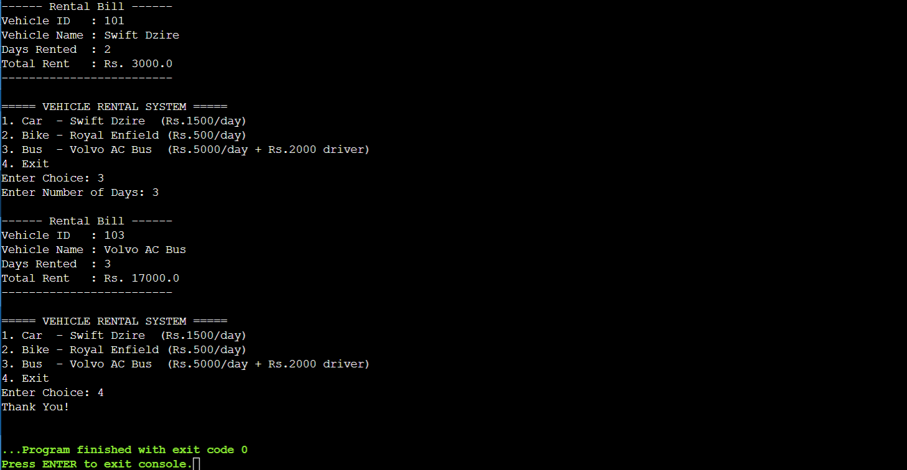
2. Shape Area Calculator using Abstract Class & Polymorphism
Design an abstract class Shape with an abstract method area(). Implement subclasses Circle, Rectangle, and Triangle. Use an array of Shape references to compute and display areas dynamically. Also, construct suitable test cases to validate area calculations and polymorphic behavior.
Code:
import java.util.Scanner;

// Abstract Class
abstract class Shape {
protected String shapeName;

Shape(String shapeName) {
this.shapeName = shapeName;
}

// Abstract Method
public abstract double area();

// Display
public void displayArea() {
System.out.println("\n------ Shape Details ------");
System.out.println("Shape : " + shapeName);
System.out.printf ("Area : %.2f%n", area());
System.out.println("---------------------------");
}
}

// Subclass - Circle
class Circle extends Shape {
private double radius;

Circle(double radius) {
super("Circle");
this.radius = radius;
}

@Override
public double area() {
return Math.PI * radius * radius;
}
}

// Subclass - Rectangle
class Rectangle extends Shape {
private double length;
private double breadth;

Rectangle(double length, double breadth) {
super("Rectangle");
this.length = length;
this.breadth = breadth;
}

@Override
public double area() {
return length * breadth;
}
}

// Subclass - Triangle
class Triangle extends Shape {
private double base;
private double height;

Triangle(double base, double height) {
super("Triangle");
this.base = base;
this.height = height;
}

@Override
public double area() {
return 0.5 * base * height;
}
}

// Main Class
public class Main {
public static void main(String[] args) {
Scanner sc = new Scanner(System.in);
Shape shapes[] = new Shape[3];
int count = 0;

int choice;
do {
System.out.println("\n===== SHAPE AREA CALCULATOR =====");
System.out.println("1. Add Circle");
System.out.println("2. Add Rectangle");
System.out.println("3. Add Triangle");
System.out.println("4. Display All Areas");
System.out.println("5. Exit");
System.out.print("Enter Choice: ");
choice = sc.nextInt();

switch (choice) {
case 1:
System.out.print("Enter Radius: ");
double r = sc.nextDouble();
shapes[count++] = new Circle(r);
System.out.println("Circle Added.");
break;
case 2:
System.out.print("Enter Length: ");
double l = sc.nextDouble();
System.out.print("Enter Breadth: ");
double b = sc.nextDouble();
shapes[count++] = new Rectangle(l, b);
System.out.println("Rectangle Added.");
break;
case 3:
System.out.print("Enter Base: ");
double base = sc.nextDouble();
System.out.print("Enter Height: ");
double h = sc.nextDouble();
shapes[count++] = new Triangle(base, h);
System.out.println("Triangle Added.");
break;
case 4:
if (count == 0) {
System.out.println("No Shapes Added.");
} else {
for (int i = 0; i < count; i++) {
shapes[i].displayArea();
}
}
break;
case 5:
System.out.println("Thank You!");
break;
default:
System.out.println("Invalid Choice.");
}
} while (choice != 5);

sc.close();
}
}
Output:
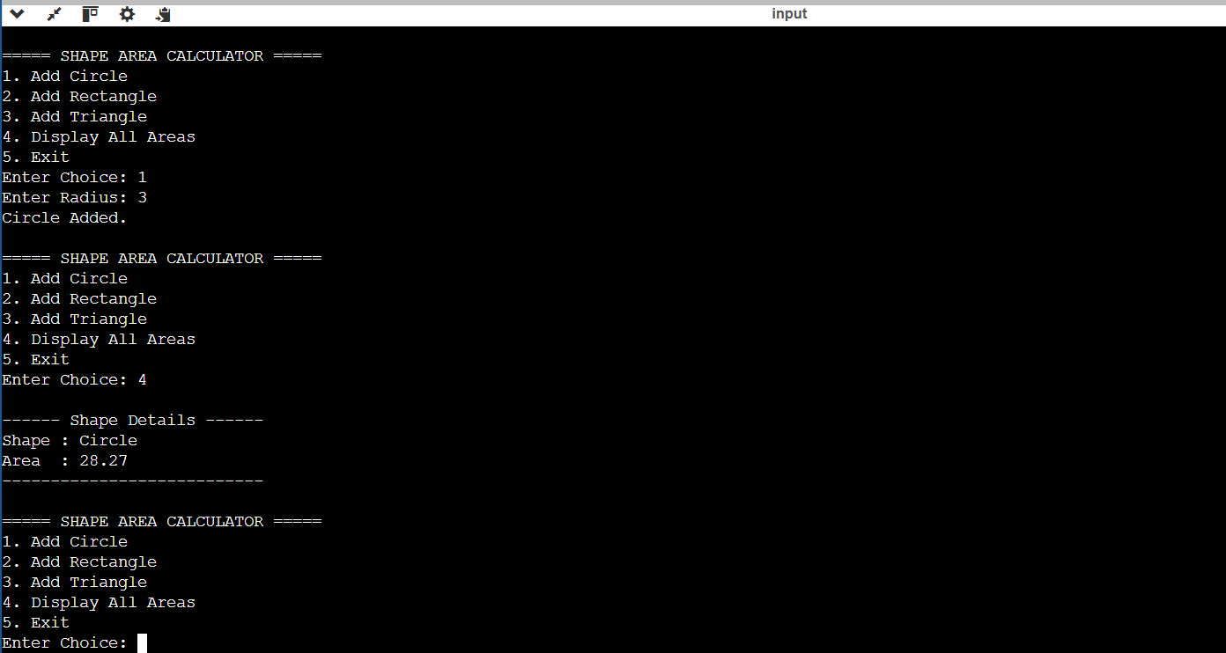
3. Online Shopping Order System using Packages
Create two packages: shopping.product and shopping.order. Implement classes Product and Order in separate packages. Import the packages into a main application that places orders and calculates the total amount. Also, construct suitable test cases to validate package usage, order placement, and bill generation.
Code:
import java.util.Scanner;

// --- Product Class ---
class Product {
private int productId;
private String productName;
private double price;
private int stock;

public Product(int productId, String productName, double price, int stock) {
this.productId = productId;
this.productName = productName;
this.price = price;
this.stock = stock;
}

public int getProductId() { return productId; }
public String getProductName() { return productName; }
public double getPrice() { return price; }
public int getStock() { return stock; }

public void reduceStock(int qty) {
if (qty <= stock) {
stock -= qty;
}
}

public void displayProduct() {
System.out.println("ID: " + productId + " | Name: " + productName +
" | Price: Rs." + price + " | Stock: " + stock);
}
}

// --- Order Class ---
class Order {
private int orderId;
private Product product;
private int quantity;

public Order(int orderId, Product product, int quantity) {
this.orderId = orderId;
this.product = product;
this.quantity = quantity;
}

public double calculateTotal() {
return product.getPrice() * quantity;
}

public void displayBill() {
System.out.println("\n======= ORDER BILL =======");
System.out.println("Order ID : " + orderId);
System.out.println("Product : " + product.getProductName());
System.out.println("Unit Price : Rs." + product.getPrice());
System.out.println("Quantity : " + quantity);
System.out.println("Total Amount : Rs." + calculateTotal());
System.out.println("=========================");
}
}

// --- Main Class ---
public class Main {
public static void main(String[] args) {
Scanner sc = new Scanner(System.in);

// Initialize product catalogue
Product catalogue[] = {
new Product(1, "Laptop", 45000, 10),
new Product(2, "Mouse", 500, 50),
new Product(3, "Keyboard", 800, 30),
};

int orderId = 1;
int choice;

do {
System.out.println("\n===== ONLINE SHOPPING SYSTEM =====");
System.out.println("1. View Products");
System.out.println("2. Place Order");
System.out.println("3. Exit");
System.out.print("Enter Choice: ");
choice = sc.nextInt();

switch (choice) {
case 1:
System.out.println("\n------ Product Catalogue ------");
for (Product p : catalogue) {
p.displayProduct();
}
break;

case 2:
System.out.print("Enter Product ID (1-3): ");
int pid = sc.nextInt();
if (pid < 1 || pid > 3) {
System.out.println("Invalid Product ID.");
break;
}
Product selected = catalogue[pid - 1];
System.out.print("Enter Quantity: ");
int qty = sc.nextInt();
if (qty > selected.getStock()) {
System.out.println("Insufficient Stock. Available: " + selected.getStock());
} else {
Order order = new Order(orderId++, selected, qty);
selected.reduceStock(qty);
order.displayBill();
}
break;

case 3:
System.out.println("Thank You!");
break;

default:
System.out.println("Invalid Choice.");
}
} while (choice != 3);

sc.close();
}
}
Output:
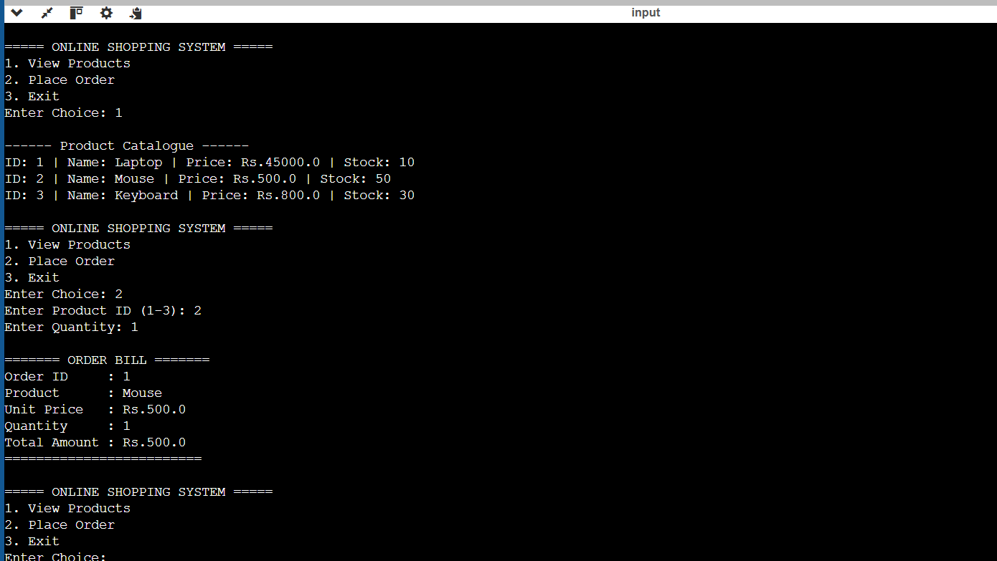
4. Student Result Analyzer using Arrays of Objects
Design a Student class containing roll number, name, and marks in three subjects. Store multiple student objects in an array and implement methods to calculate total, average, grade, and class topper. Also, construct suitable test cases to validate grading and topper identification.
Code:
import java.util.Scanner;

class Student {
protected int rollNo;
protected String studentName;
protected double mark1;
protected double mark2;
protected double mark3;

Student(int rollNo, String studentName, double mark1, double mark2, double mark3) {
this.rollNo = rollNo;
this.studentName = studentName;
this.mark1 = mark1;
this.mark2 = mark2;
this.mark3 = mark3;
}

public double calculateTotal() {
return mark1 + mark2 + mark3;
}

public double calculateAverage() {
return calculateTotal() / 3.0;
}

public String calculateGrade() {
double avg = calculateAverage();
if (avg >= 90) return "A+";
else if (avg >= 75) return "A";
else if (avg >= 60) return "B";
else if (avg >= 50) return "C";
else if (avg >= 35) return "D";
else return "Fail";
}

public void displayResult() {
System.out.println("\n------ Student Result ------");
System.out.println("Roll No : " + rollNo);
System.out.println("Name : " + studentName);
System.out.println("Mark 1 : " + mark1);
System.out.println("Mark 2 : " + mark2);
System.out.println("Mark 3 : " + mark3);
System.out.println("Total : " + calculateTotal());
System.out.printf ("Average : %.2f%n", calculateAverage());
System.out.println("Grade : " + calculateGrade());
System.out.println("----------------------------");
}
}

public class Main {
public static void main(String[] args) {
Scanner sc = new Scanner(System.in);
Student students[] = new Student[50];
int count = 0;

int choice;
do {
System.out.println("\n===== STUDENT RESULT ANALYZER =====");
System.out.println("1. Add Student");
System.out.println("2. Display All Results");
System.out.println("3. Find Class Topper");
System.out.println("4. Exit");
System.out.print("Enter Choice: ");
choice = sc.nextInt();

switch (choice) {
case 1:
System.out.print("Enter Roll No: ");
int roll = sc.nextInt();
sc.nextLine();
System.out.print("Enter Name: ");
String name = sc.nextLine();
System.out.print("Enter Mark 1: ");
double m1 = sc.nextDouble();
System.out.print("Enter Mark 2: ");
double m2 = sc.nextDouble();
System.out.print("Enter Mark 3: ");
double m3 = sc.nextDouble();
students[count++] = new Student(roll, name, m1, m2, m3);
System.out.println("Student Added Successfully.");
break;

case 2:
if (count == 0) {
System.out.println("No Students Added.");
} else {
for (int i = 0; i < count; i++) {
students[i].displayResult();
}
}
break;

case 3:
if (count == 0) {
System.out.println("No Students Added.");
} else {
Student topper = students[0];
for (int i = 1; i < count; i++) {
if (students[i].calculateTotal() > topper.calculateTotal()) {
topper = students[i];
}
}
System.out.println("\n===== CLASS TOPPER =====");
topper.displayResult();
}
break;

case 4:
System.out.println("Thank You!");
break;

default:
System.out.println("Invalid Choice.");
}
} while (choice != 4);

sc.close();
}
}
Output:
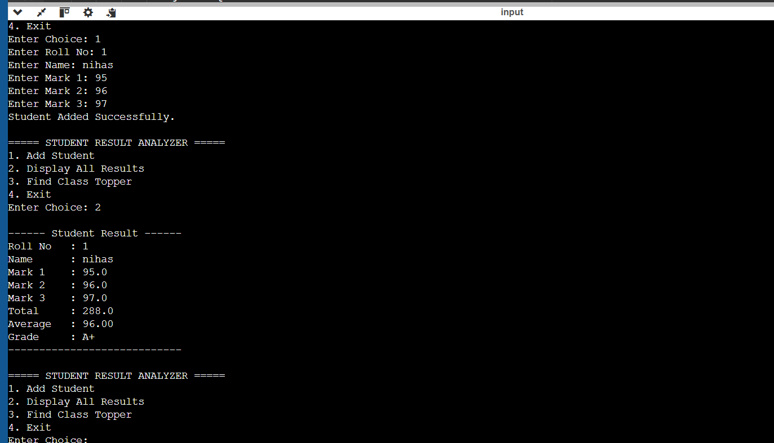
5. Smart Home Device Controller using Hierarchical Inheritance
Develop a smart home system with a base class Device and derived classes Light, Fan, and AirConditioner. Implement methods to turn devices on/off and display power consumption. Use polymorphism to control devices through a common reference. Also, construct suitable test cases to validate device operations and power calculations.
Code:
import java.util.Scanner;

// Base Class
class Device {
protected int deviceId;
protected String deviceName;
protected boolean isOn;

Device(int deviceId, String deviceName) {
this.deviceId = deviceId;
this.deviceName = deviceName;
this.isOn = false;
}

public void turnOn() {
isOn = true;
System.out.println(deviceName + " is turned ON.");
}

public void turnOff() {
isOn = false;
System.out.println(deviceName + " is turned OFF.");
}

public double getPowerConsumption() {
return 0;
}

public void displayStatus() {
System.out.println("\n------ Device Status ------");
System.out.println("Device ID : " + deviceId);
System.out.println("Device Name : " + deviceName);
System.out.println("Status : " + (isOn ? "ON" : "OFF"));
System.out.println("Power : " + getPowerConsumption() + " Watts");
System.out.println("---------------------------");
}
}

// Derived Class - Light
class Light extends Device {
private double watts;

Light(int deviceId, String deviceName, double watts) {
super(deviceId, deviceName);
this.watts = watts;
}
@Override
public double getPowerConsumption() {
return isOn ? watts : 0;
}
}

// Derived Class - Fan
class Fan extends Device {
private int speed; // 1=Low, 2=Medium, 3=High
private double baseWatts;

Fan(int deviceId, String deviceName, int speed, double baseWatts) {
super(deviceId, deviceName);
this.speed = speed;
this.baseWatts = baseWatts;
}

@Override
public double getPowerConsumption() {
return isOn ? baseWatts * speed : 0;
}

public void setSpeed(int speed) {
this.speed = speed;
System.out.println(deviceName + " speed set to " + speed);
}
}

// Derived Class - AirConditioner
class AirConditioner extends Device {
private int temperature;
private double watts;

AirConditioner(int deviceId, String deviceName, int temperature, double watts) {
super(deviceId, deviceName);
this.temperature = temperature;
this.watts = watts;
}

@Override
public double getPowerConsumption() {
return isOn ? watts : 0;
}

public void setTemperature(int temperature) {
this.temperature = temperature;
System.out.println(deviceName + " temperature set to " + temperature + "°C");
}
}

// Main Class
public class Main {
public static void main(String[] args) {
Scanner sc = new Scanner(System.in);

// Polymorphic Device array
Device devices[] = new Device[3];
devices[0] = new Light(1, "Living Room Light", 60);
devices[1] = new Fan(2, "Bedroom Fan", 3, 25);
devices[2] = new AirConditioner(3, "Hall AC", 22, 1500);

int choice;
do {
System.out.println("\n===== SMART HOME CONTROLLER =====");
System.out.println("1. Turn ON a Device");
System.out.println("2. Turn OFF a Device");
System.out.println("3. Display All Device Status");
System.out.println("4. Total Power Consumption");
System.out.println("5. Exit");
System.out.print("Enter Choice: ");
choice = sc.nextInt();

switch (choice) {
case 1:
System.out.print("Enter Device ID (1-3): ");
int onId = sc.nextInt();
if (onId >= 1 && onId <= 3) {
devices[onId - 1].turnOn();
} else {
System.out.println("Invalid Device ID.");
}
break;

case 2:
System.out.print("Enter Device ID (1-3): ");
int offId = sc.nextInt();
if (offId >= 1 && offId <= 3) {
devices[offId - 1].turnOff();
} else {
System.out.println("Invalid Device ID.");
}
break;

case 3:
for (Device d : devices) {
d.displayStatus();
}
break;

case 4:
double total = 0;
for (Device d : devices) {
total += d.getPowerConsumption();
}
System.out.println("\nTotal Power Consumption: " + total + " Watts");
break;

case 5:
System.out.println("Thank You!");
break;

default:
System.out.println("Invalid Choice.");
}
} while (choice != 5);

sc.close();
}
}
Output:

